Text and image generation

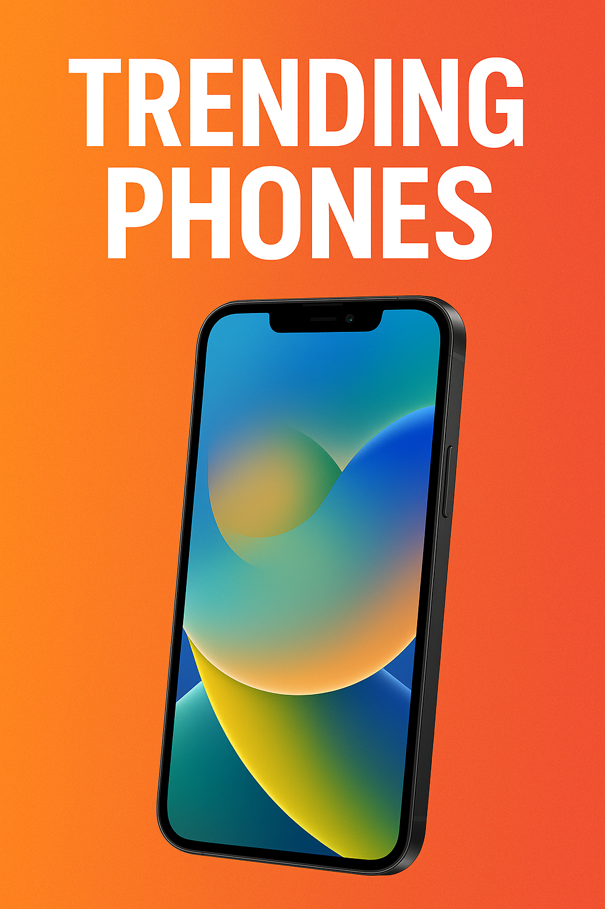

1. Phone: Nothing Phone (2)

Guided Text
- Design: Transparent back showing internal components
- Unique Feature: “Glyph Interface” — lights that pulse for notifications, calls, and alerts
- Why it’s interesting: Focuses on minimalism and clean Android, but adds a futuristic aesthetic
- Who it’s for: People who want a phone that looks different and feels modern without bloat

Unguided Text
The Nothing Phone (2) looks like something from a sci-fi movie. Its transparent back glows with subtle LED patterns that feel alive, almost like the phone has a personality. It’s clean, fast, and refreshingly simple, making it stand out in a world of nearly identical rectangles.

📱 2. Phone: Samsung Galaxy Z Fold 5

Guided Text
- Design: Foldable phone-tablet hybrid with a central hinge
- Unique Feature: Opens into a 7.6-inch tablet
- Why it’s interesting: It completely changes how you multitask — run 3 apps at once, drag files, etc.
- Who it’s for: People who love productivity and futuristic form factors

Unguided Text
The Galaxy Z Fold 5 feels like carrying a tiny tablet in your pocket. It folds open into a massive screen that makes movies, multitasking, and gaming feel totally different from a normal phone. You pick it up and instantly feel like the future arrived early.

📱 3. Phone: ASUS ROG Phone 8 Pro

Guided Text
- Design: Gamer-focused, bold lines, RGB effects
- Unique Feature: Ultra-high refresh rate and cooling system
- Why it’s interesting: Built specifically for gaming — triggers, high-speed performance, and insane battery
- Who it’s for: Gamers who want a phone made for performance and tournaments

Unguided Text
The ROG Phone 8 Pro is basically a handheld gaming console disguised as a phone. It’s powerful, cool (literally), and the RGB lighting gives it a sleek cyberpunk vibe. When you fire up a game on it, everything feels smoother, faster, and far more intense than on a regular smartphone.

If you want, I can make:
- longer descriptions
- comparisons between the phones
- a list of 10+ interesting phones
- creative fictional phones
Just tell me!
ss

